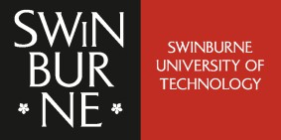

ICT80004 Mid-Internship Project Review Form - Check In
To be discussed during the mid-semester visit and submitted to Canvas by week 8.
Student Name: Arun Ragavendhar Arunachalam Palaniyappan ID: 104837257
Organisation: Commonwealth Scientific and Industrial Research Organization (CSIRO) -Data61

Industry Supervisor:
Dr. Shigang Liu
Date of Visit: 12/09/2025

Student Self-Assessment

Your perception  Knowledge | I’m getting the  opportunities | I love to have more  opportunities | Give one example in relation to your rating
1. awareness of a range of issues  associated with professional practice |  |  | I gained awareness of real-world IT risks, especially how social engineering and unsafe code can cause vulnerabilities. I also understood the importance of ethics and responsible testing.
2. professional and personal skills |  |  | I improved communication through weekly meetings, presentations, and documentation. I learned to clearly explain technical findings to both technical and non-technical people.
3. practical skills and theoretical  knowledge into an IT industry context |  |  | I applied my academic knowledge of cybersecurity and AI by testing prompt injection and code vulnerabilities on real models, gaining hands-on experience.
4. understanding of business processes  and organisational structures |  |  | I saw how agile processes (two-week sprints, reviews, feedback loops) guide research work in CSIRO, and how client and university supervisors coordinate in industry projects.
5. professional contacts and networks  within the IT industry |  |  | This project gave me exposure to industry experts and supervisors at CSIRO, which helped me understand professional expectations and build useful networks.

Student’s Comments (to be completed prior to the mid-semester visit):
During the first half of my internship (Weeks 1–6), I applied classroom knowledge to real industry problems by testing AI models for prompt injection and insecure code examples. I designed, tested and documented malicious-style prompts based on a range of social-engineering tactics (for example: urgency, impersonation and persuasion), measured their attack success rates, and recorded the outcomes. These hands-on tasks improved my technical skills and gave me a clear view of how risks are identified and managed in practice. I also strengthened my communication by presenting weekly updates, preparing the mid-internship review, and keeping concise documentation. Working closely with my industry and academic supervisors showed me how research projects are organised and guided in a professional setting. Overall, this phase has increased my confidence and motivated me to contribute even more in the second half of the internship.

Industry Supervisor’s Comments (to be completed prior or during the mid-semester visit):
Arun has made excellent progress in exploring the application of prompt injection within the domain of vulnerability security. He has carefully studied relevant literature, actively engaged with large language models for experimental exploration, and demonstrated strong initiative in conducting experiments. His progress so far has been smooth and productive. I am particularly impressed by Arun's diligence and dedication to his research. Moreover, he has shown the ability to plan his work effectively, aligning his progress with the supervisor’s guidance. Overall, I am very pleased with Arun’s performance and am confident in his continued success in this project.

Academic Supervisor’s Comments (to be completed during the mid-semester visit):
Arun has demonstrated strong initiative and high-level technical skills in applying AI models to real-world cybersecurity challenges. His ability to integrate academic knowledge with industry practices, along with clear communication and consistent progress, is commendable. I am confident he will continue to deliver impactful outcomes in the second half of his internship.

Signatures:

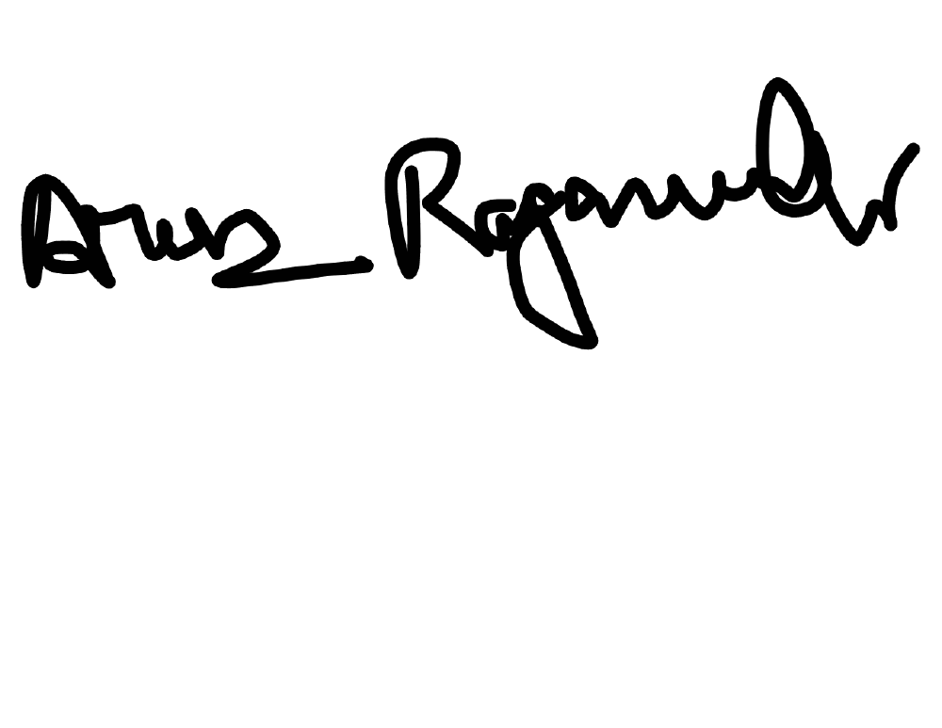

Student

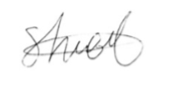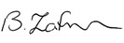

Industry Supervisor Academic Supervisor

